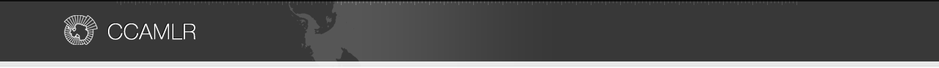

 | Net configuration
Net measurements |  | Net 1 | Net 2 | Other net(s)
Net-mouth opening height (m) |  | 40 | 40
Net-mouth opening width (m) |  | 72 | 72
Total net length (m) including codend,  Measured along the centerline of the net |  | 167.6 | 167.6
Codend-mouth opening height (m) |  | 1.5 | 1.5
Codend-mouth opening width (m) |  | 3 | 3
Codend length (m) |  | 32 | 32
Codend mesh size (mm;stretched mesh) |  | Inner 15  Outer 100 | Inner 15  Outer 100

Net diagram(s): KWANG JA HO

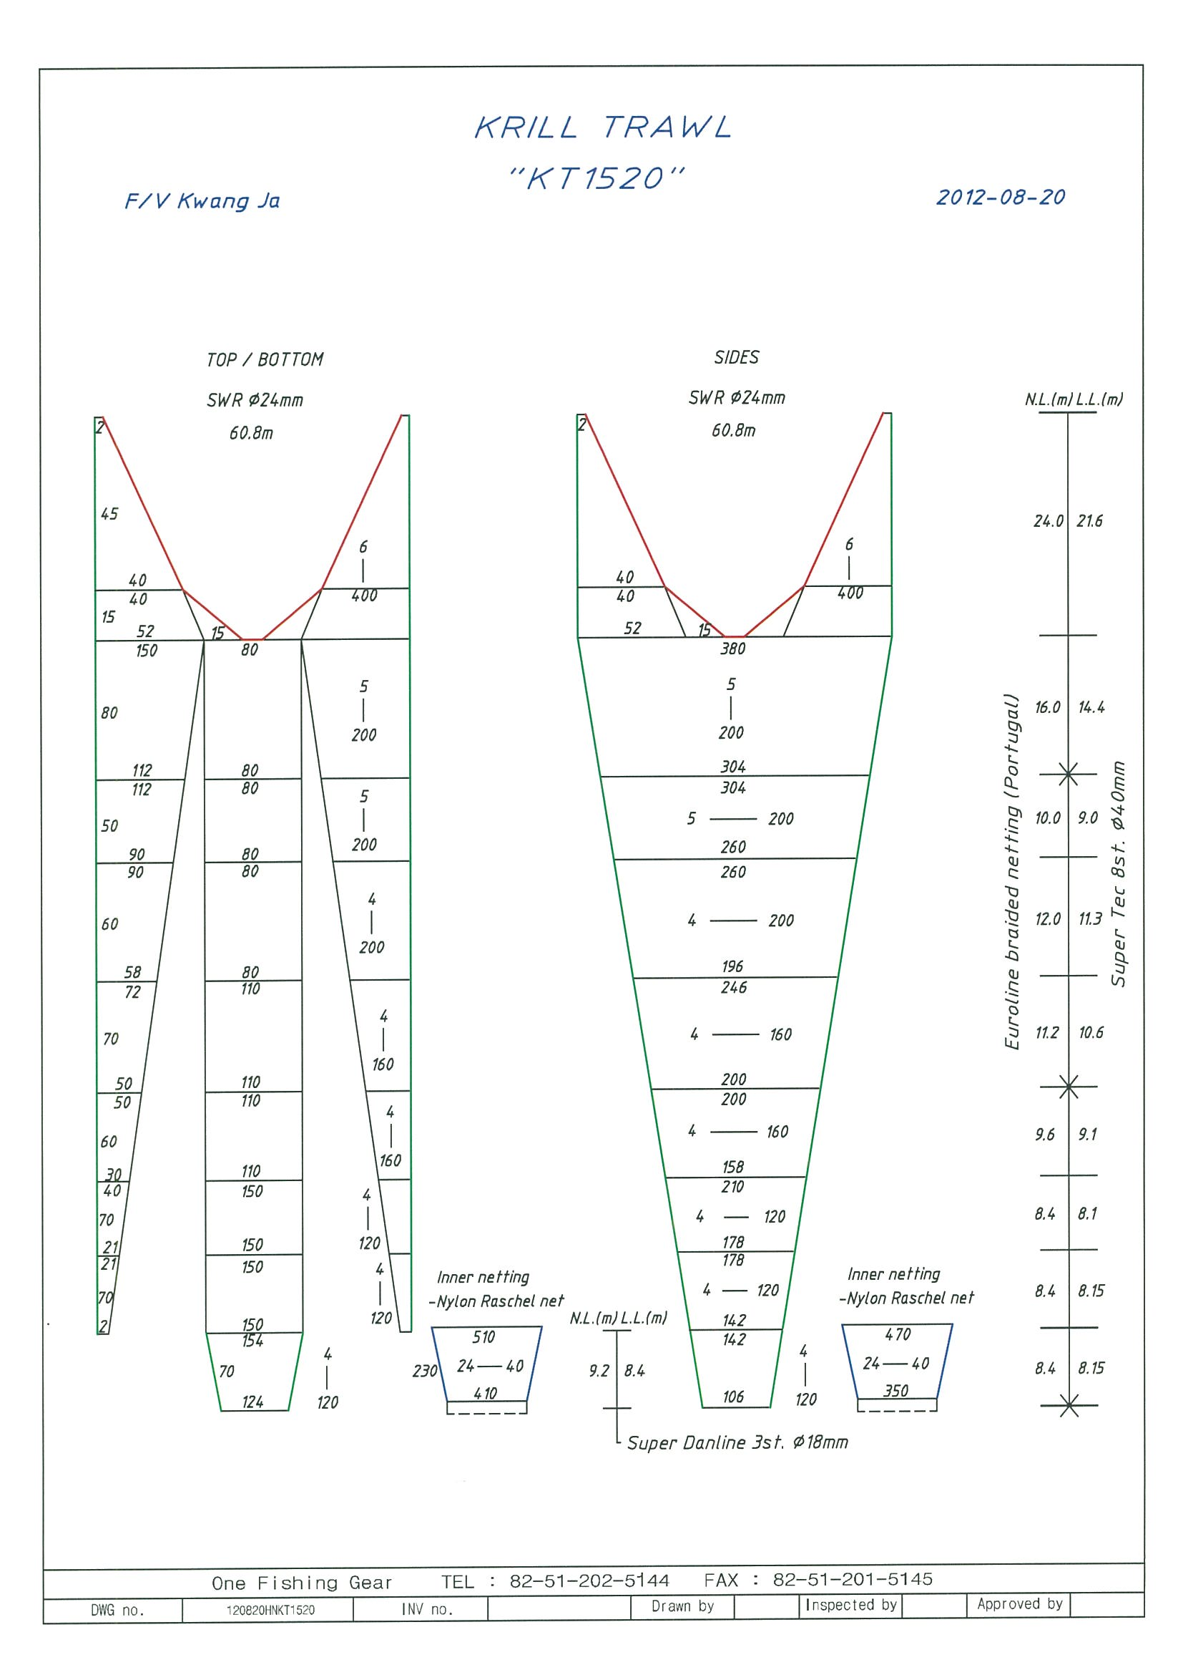

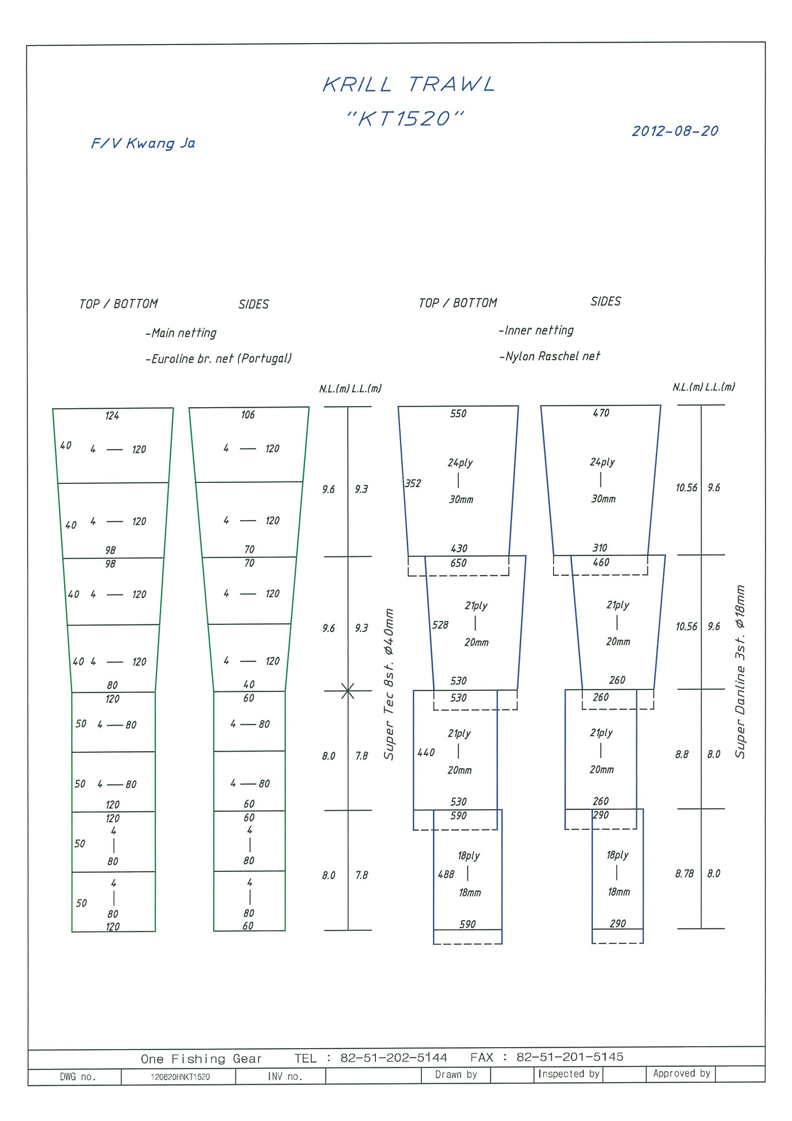

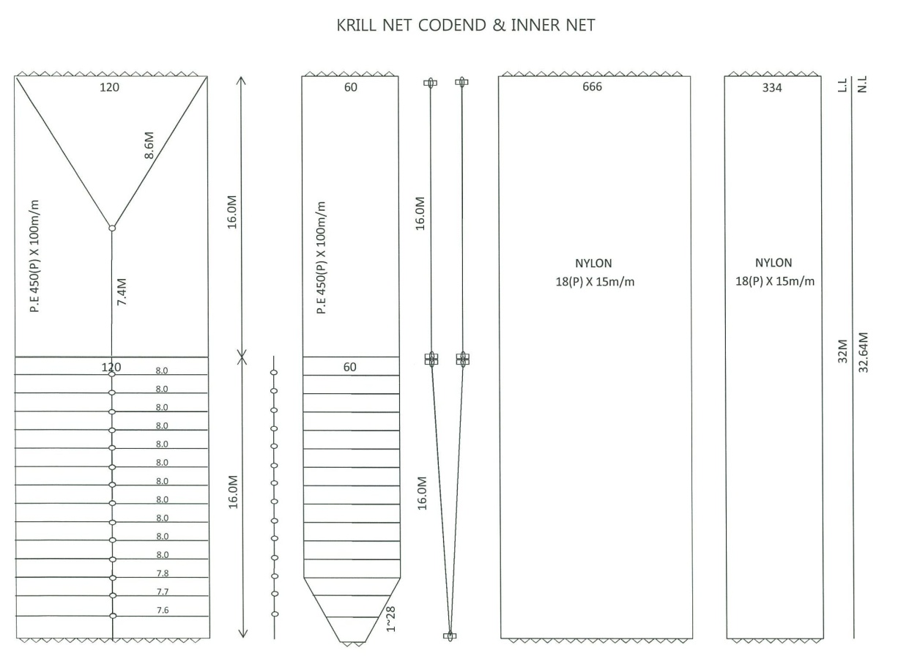

For each net used, or any change in net configuration, refer to the relevant net diagram in the CCAMLR fishing gear library if available ( www.ccamlr.org/node/74407), or submit a detailed diagram and description to the forthcoming meeting of WG-EMM. Net diagrams must include:

- Length and width of each trawl panel (in sufficient detail to allow calculation of the angle of each panel with respect to water flow.)
- Mesh size (inside measurement of stretched mesh based on the procedure in Conservation Measure 22-01), shape (e.g. diamond shape) and material (e.g. polypropylene).
- Mesh construction (e.g. knotted, fused).
- Details of streamers used inside the trawl (design, location on panels, indicate ‘nil’ if streamers are not in use); streamers prevent krill fouling the mesh or escaping.

